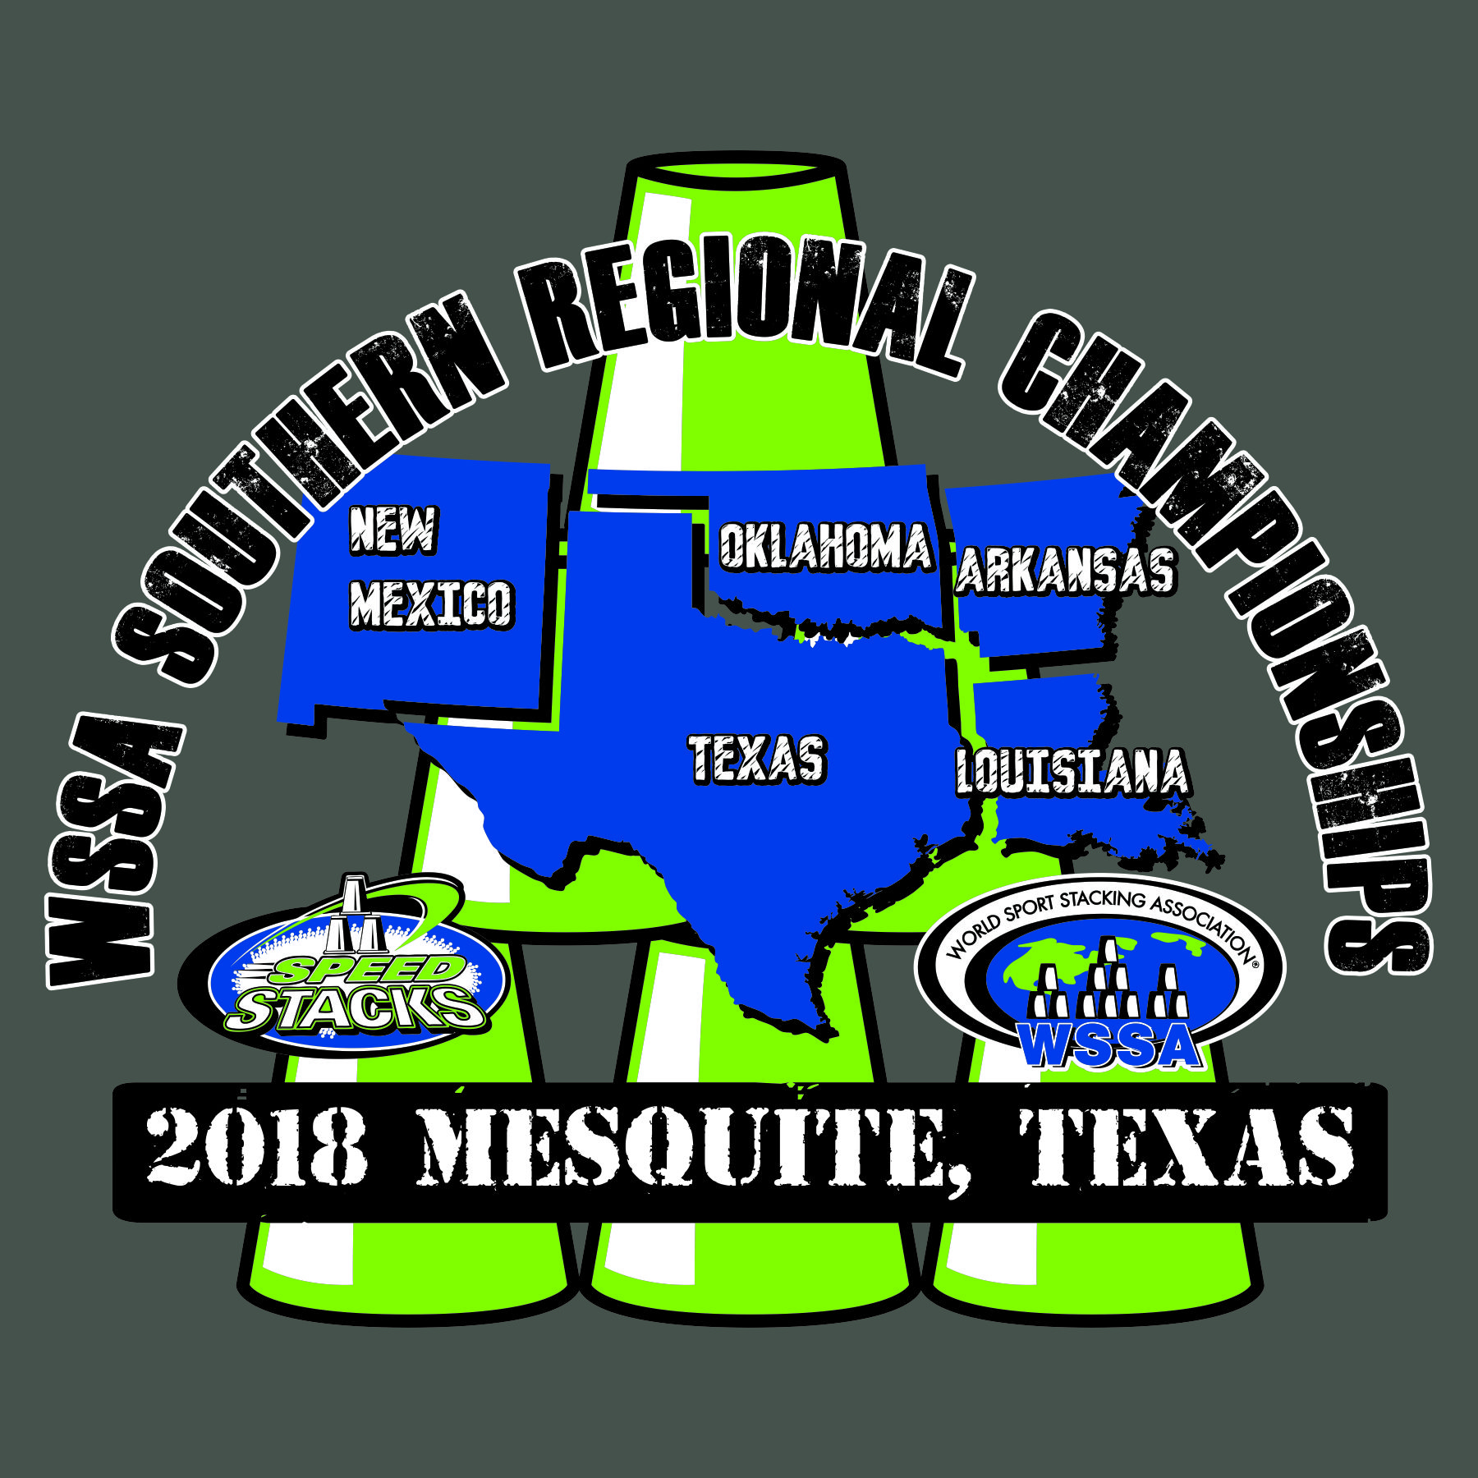

Schedule of Events

*All times approximate*

7:30-9:00 Check-in

8:45-9:00 Coaches Meeting

9:00-9:15 Opening Ceremonies

9:15-11:45 Prelims Individual 3-3-3, 3-6-3, Cycle, Doubles, Child/Parent Doubles, Timed 3-6-3 Relay

11:45-12:45 3-6-3 H-T-H Relay (Awards given after Championship Race)

12:45-1:15 Break

1:15-1:45 Timed 3-6-3 Relay Finals (Awards given at Age Division table)

1:45-2:30 Age Division Doubles, Child/Parent Doubles Finals

(Awards given at Age Division Table)

2:30-3:15 3-3-3 Finals (Awards given at Age Division Table)

3:15-4:00 3-6-3 Finals (Awards given at Age Division Table)

4:00-4:45 Cycle Finals (Awards given at Age Division Table)

4:45-5:00 Stack-Out