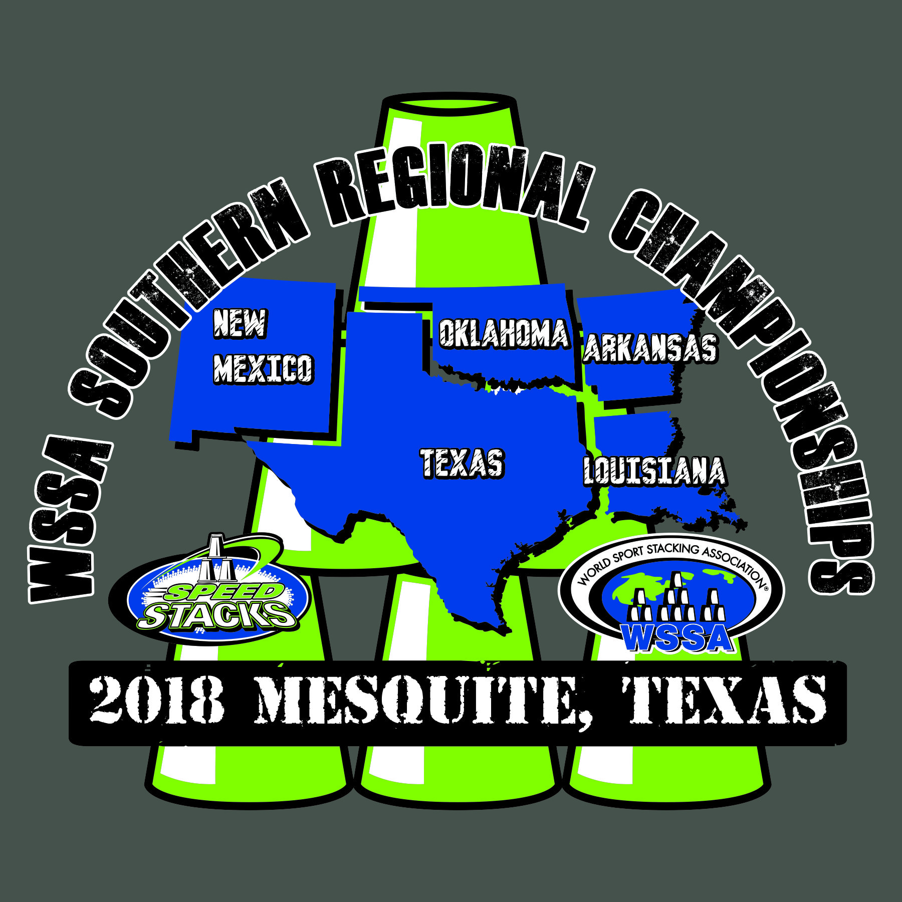**INDIVIDUAL STACKER REGISTRATION**

**2018 WSSA Southern Regional**

**Sport Stacking Championships**

**Saturday, March 3rd, 2018**

**9:00 a.m.-5:00 p.m.**

**John Horn High School**

**3300 E Cartwright Road**

**Mesquite, TX 75181**

Participant School/ __________________________________________

Organization

Participant Name ________________________ ________________________

First Last

Participant Phone # (____) ____________________ email ____________________________________

Participant Birth Date _________________ Participant Age _____________

Circle Participant Age Division… **Age division is based on participant’s age on the day of the tournament.**

**6 & Under** **7-8** **9-10** **11-12** **13-18** **19 & Up** Gender: (circle one) Male Female

Age Divisions are subject to change based on number of participants.

All Individual events are separated by gender. The top five in each division will be awarded.

**Entry Fee $20.00**

***With entry fee, students may participate in any or all of the following events.***

***3-3-3, 3-6-3, Cycle, 3-6-3 Timed Relay, 3-6-3 Head to Head Relay, Doubles, Child/Parent Doubles***

***Separate forms for Relay and Doubles must be completed. All relay teams must be submitted prior to the tournament. There will be no relay teams accepted/formed on the day of the tournament.***

***Cash or check is accepted with Drivers License number. Checks should be made to Mesquite ISD.***

***Speed Stacks products and event t-shirts will be sold. Concessions will also be available.***

***Please return this form and entry fee to:***

***Motley Elementary***

***Attn: Ryan Davis***

***3719 Moon Dr.***

***Mesquite, TX 75150***

**All entries are due/postmarked by February 23rd, 2018.Tournament fee after this date will be $30.00**

**Parent Agreement: I understand that my child will need to be supervised during the competition. I give my consent for my child to compete in the above-mentioned events and verify the date of birth listed above. In addition, I am granting the WSSA and their affiliate’s permission to film and/or record my child or the likeness thereof. Such film/recordings may be sold for promotional use by the WSSA.**

______________________________________ Date _______________

Parent/Guardian Signature

Contact information: Ryan Davis (972) 882-5080 [rldavis@mesquiteisd.org](mailto:rldavis@mesquiteisd.org)

or Wendi Hatley (972) 882-7413 [whatley@mesquiteisd.org](mailto:whatley@mesquiteisd.org)