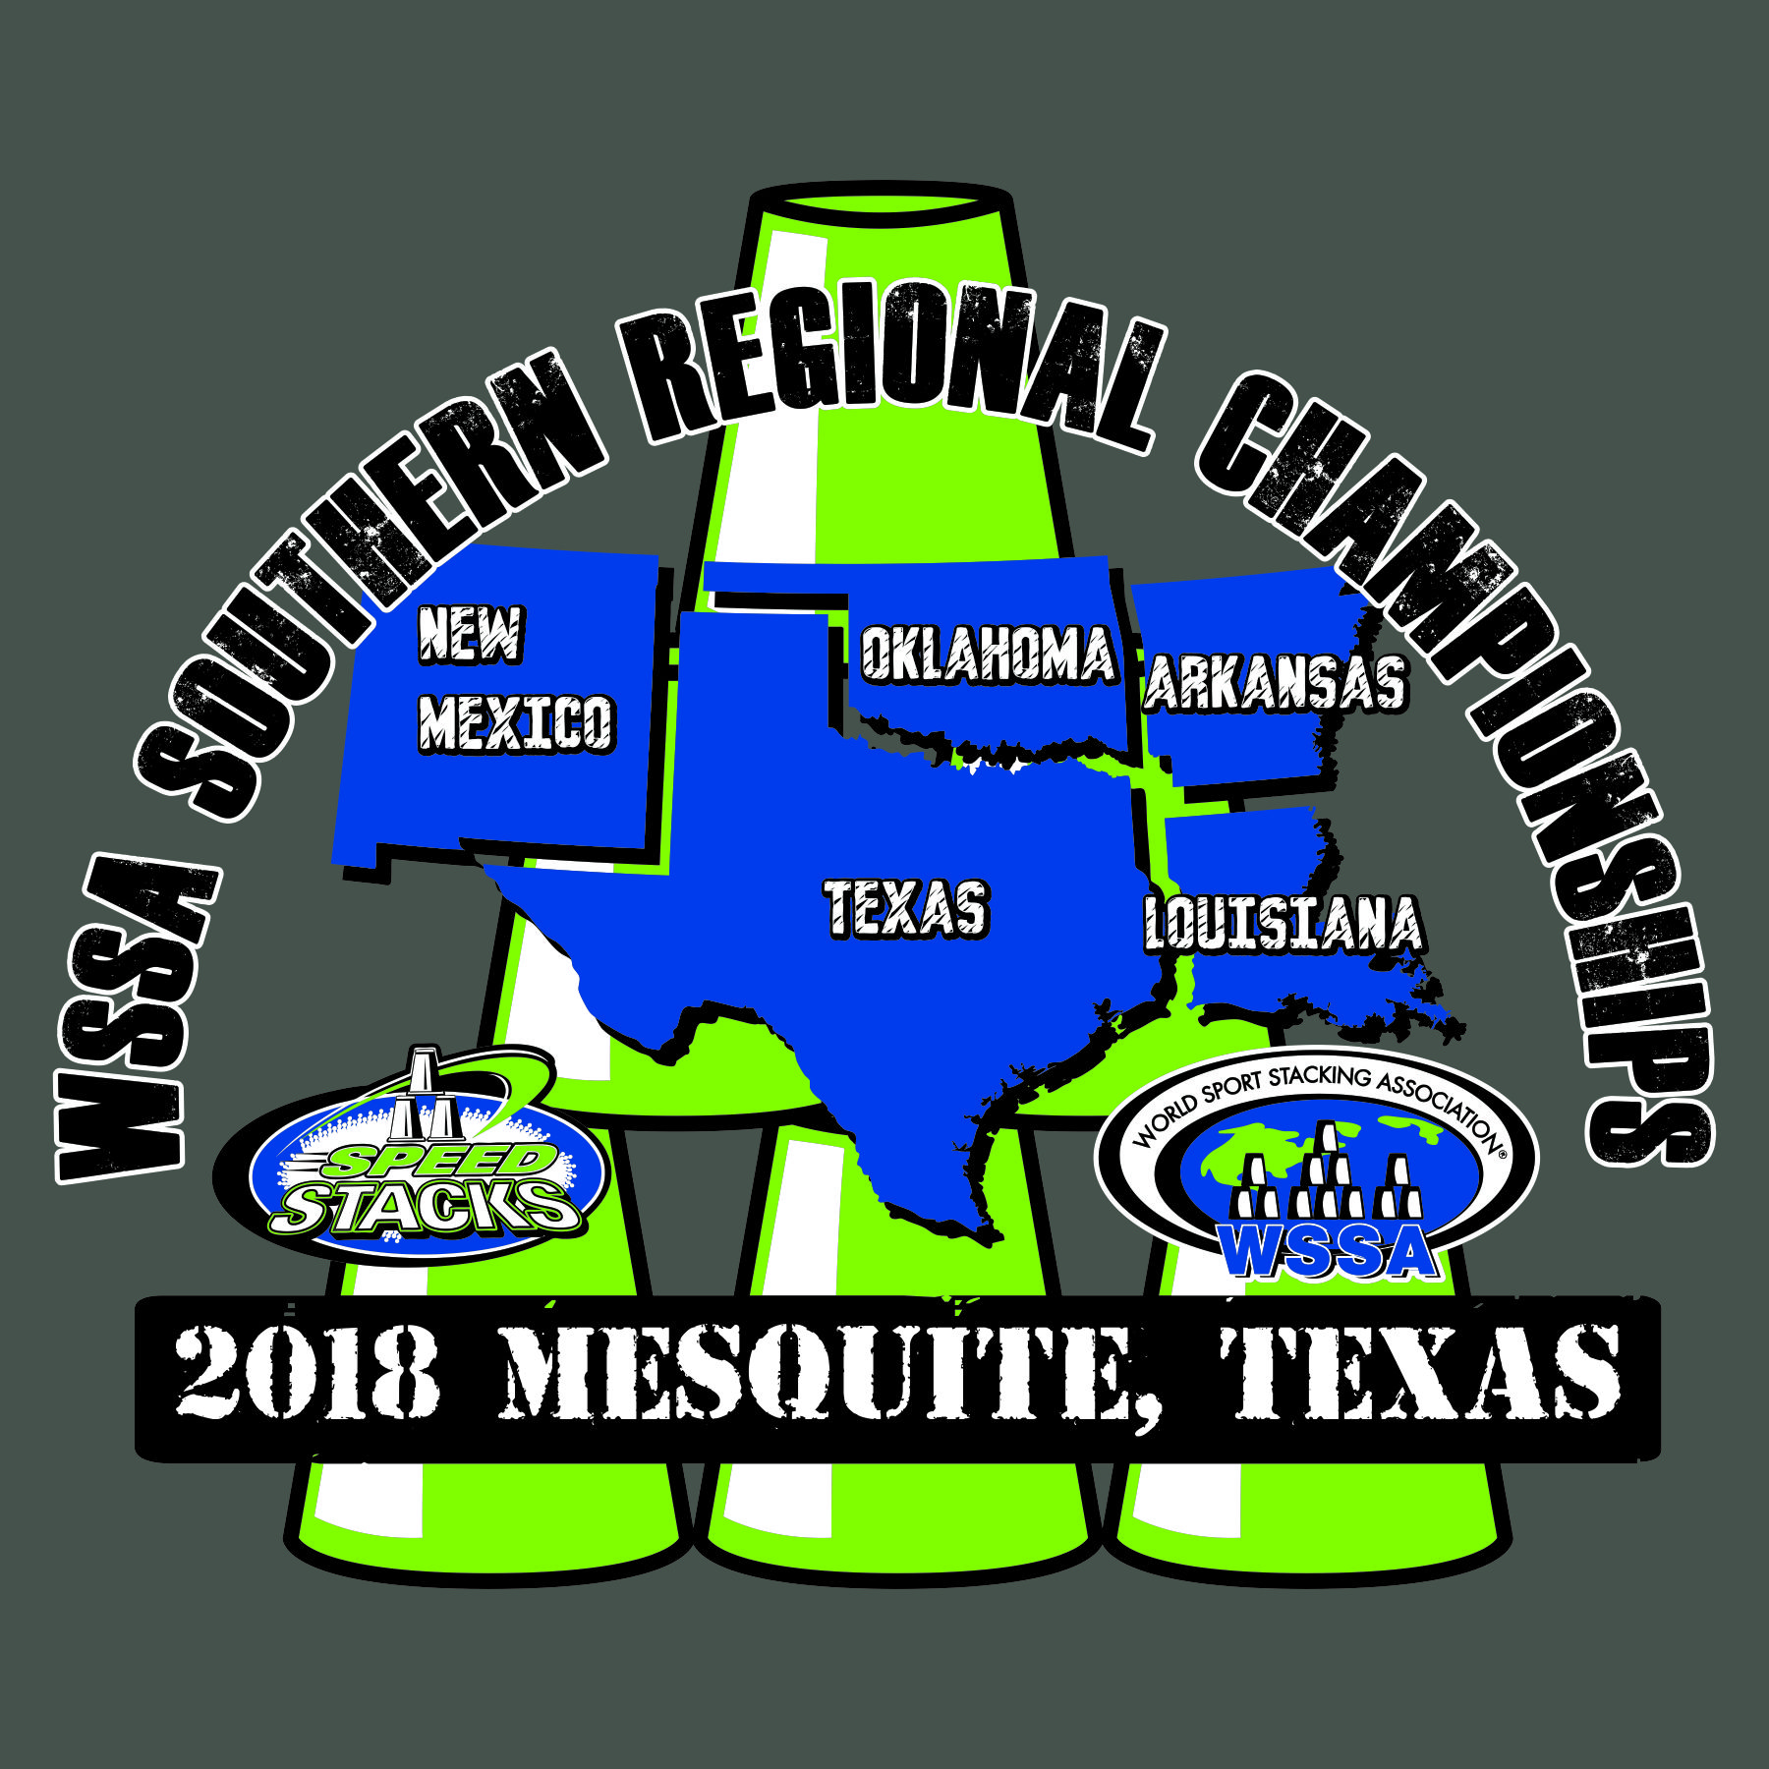**Special Stacker Registration**

**2018 WSSA Southern Regional**

**Sport Stacking Championships**

**Saturday, March 3rd, 2018**

**9:00 a.m.-5:00 p.m.**

**John Horn High School**

**3300 E Cartwright Road**

**Mesquite, TX 75181**

Participant School/ __________________________________________

Organization

Participant Name ________________________ ________________________

First Last

Participant Phone # (____) ____________________ email ____________________________________

Participant Birth Date _________________ Participant Age _____________

Circle Participant Age Division… **Age division is based on participant’s age on the day of the tournament.**

**11 U 12 & Up**

Age Divisions are subject to change based on number of participants.

All Special Stackers Age Divisions are Male & Female Combined. The top five in each division will be awarded.

**Entry Fee $20.00**

***With entry fee, students may participate in any or all of the following events.***

***3-3-3, 3-6-3, Cycle, 3-6-3 Timed Relay, 3-6-3 Head to Head Relay, Doubles, Child/Parent Doubles***

***Separate forms for Relay and Doubles must be completed. All relay teams must be submitted prior to tournament.* There will be no relay teams accepted/formed on the day of the tournament.**

***Cash or check is accepted with Drivers License number. Checks should be made to Mesquite ISD.***

***Speed Stacks products and event t-shirts will be sold. Concessions will also be available.***

**Please return this form and entry fee to*:***

***Motley Elementary***

***Attn: Ryan Davis***

***3719 Moon Dr.***

***Mesquite, TX 75150***

***All entries are due/postmarked by February 23rd, 2018. Tournament fee after this date will be $30.00***

**Parent Agreement: I understand that my child will need to be supervised during the competition. I give my consent for my child to compete in the above-mentioned events and verify the date of birth listed above. In addition, I am granting the WSSA and their affiliates permission to film and/or record my child or the likeness thereof. Such film/recordings may be sold for promotional use by the WSSA.**

______________________________________ Date _______________

Parent/Guardian Signature

Contact information: Ryan Davis (972) 882-5080 [rldavis@mesquiteisd.org](mailto:rldavis@mesquiteisd.org)

or Wendi Hatley (972) 882-7413 [whatley@mesquiteisd.org](mailto:whatley@mesquiteisd.org)