**Doubles Registration**

2018 Southern Regional

Sport Stacking Championships

Doubles teams will stack in the Age Division of oldest stacker. All Doubles competition will stack the Cycle. *Exceptions to this are Special Stackers, who stack the 3-6-3.* *A Special Stacker may compete in the Open Division but will be required to stack the Cycle.* Stackers may only compete on one Age Division Doubles Team. Age Divisions are subject to change based on number of participants. The top five teams in each division will be awarded.

**Circle Age Division**

**6 & Under 8 & Under 10 & Under 12 & Under 18 & Under 19 & Up**

Stacker 1 __________________________________ __________________________________

First Name Last Name

Phone # ________________________________ email______________________________________

Birth Date ________________ Age ________

Stacker 2 __________________________________ __________________________________

First Name Last Name

Phone # ________________________________ email______________________________________



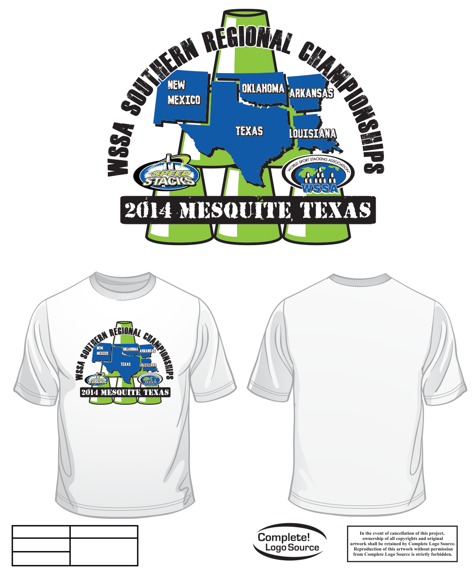

Birth Date ________________ Age ________

