*WSSA 2018 11TH ANNUAL*

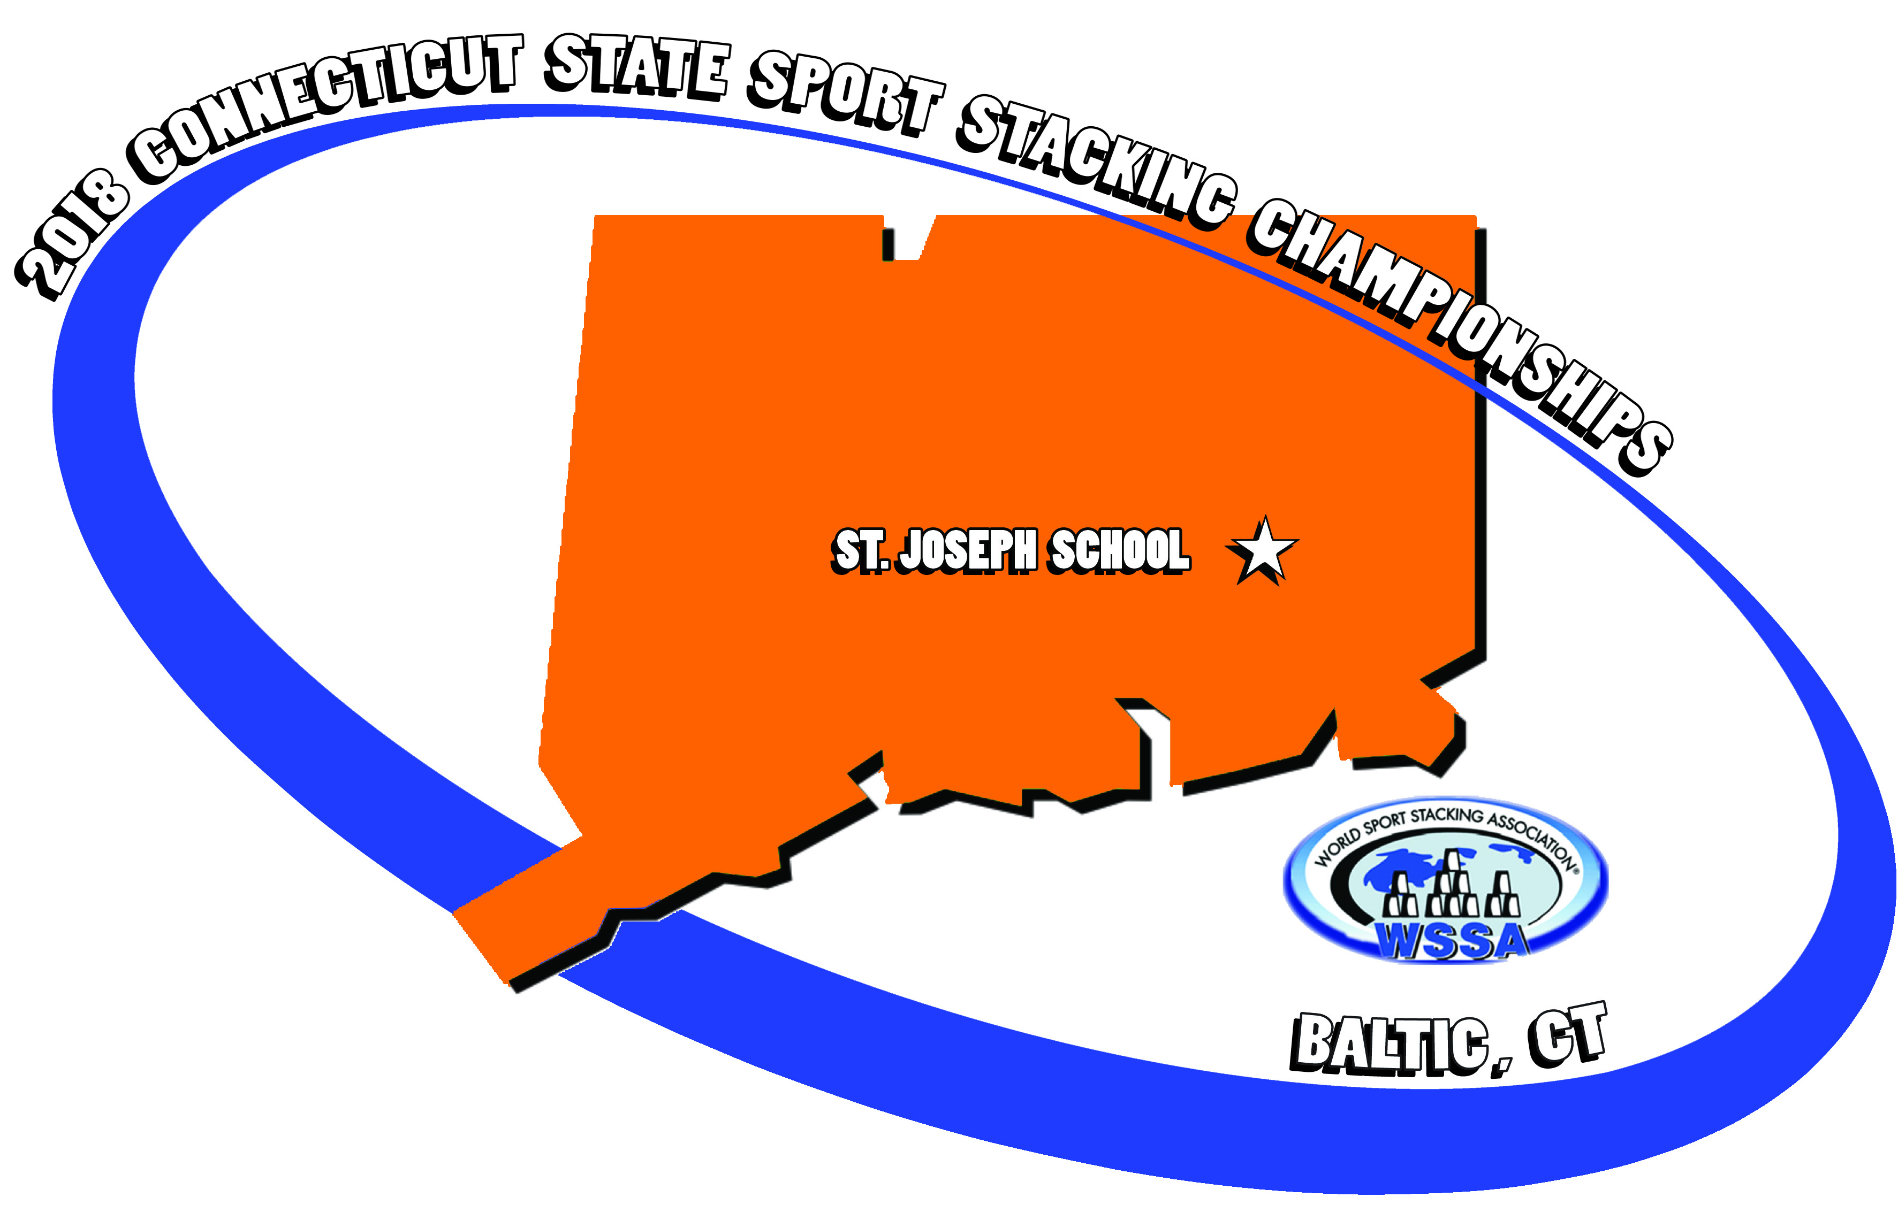

*CONNECTICUT STATE*

*SPORTSTACKING CHAMPIONSHIPS*

*SATURDAY, OCTOBER 27th, 2018 ( 8AM-3PM )*

*ST. JOSEPH SCHOOL-10 SCHOOL HILL RD.*

*BALTIC, CT 06330*

*DOORS OPEN-6:00 AM*

**PLEASE PRINT**

**\*\*YOU MUST REGISTER YOUR NEW TEAM BEFORE COMPETITION BEGINS AT 8:00AM**

I’m on a relay team. I’m not on a relay team-will try to join one at the Championship. *TIMED 3-6-3 RELAYS

Relay Team Name_________________________________ Relay Team Coordinator_________________________

1)NAME___________________________ ___________ AGE_______STATE_____________

2)NAME__________________________________________AGE_______STATE_____________

3)NAME__________________________________________AGE_______STATE_____________

4)NAME__________________________________________AGE_______STATE_____________

5)NAME__________________________________________AGE_______STATE_____________(optional)

*all relay teams must have at least 4 members-5th member is optional.

Stacker’s Name__________________________________________ Home PH# ( ) _____________________

Date of Birth (Month/Day/Year) ______/________/_______ Age on 10/27/18_______ Male_______ Female_________

Age Division *(circle one)*  6 & under, 7- 8, 9- 10, 11- 12, 13-14, 15-18, Collegiate (19-24), Masters (25 & up) **Avg. 3-6-3 Time______________**

Home Address______________________________________City/Town___________________St._____ Zip Code_____________

School/Organization_____________________________________ Parent/Guardian____________________________________ WORK PH# (________) _____________________________ CELL PH# (________) ______________________________

EMAIL ADDRESS_________________________________________________________________

Would be willing to be a judge during the competition(age 14 or older) Yes__________ No___________

I’m on a doubles team I’m not on a doubles team-will try to join one at the championship. *CYCLE STACK

DOUBLES TEAM MEMBERS: 1)______________________________AGE_______2)______________________________AGE_______

PARENT/CHILD DOUBLES: 1)_______________________________AGE_______2)______________________________AGE_______

**MUST REGISTER NEW TEAMS BEFORE COMPETITION BEGINS AT 8:00AM

**Tournament Director will ***NOT*** form doubles or relay teams-it is up to each stacker to do this!!!

REGISTRATION FEE **(Due by Monday, Oct.. 15 , 2018)**

**$35** All outside competitors **$12** Students from St. Joes, Sacred Heart, and St. James

**$20**  2018 Championship T-shirts Pre-order**……**check below your size-shirts will be ordered on ***October 8!!!!!***

***\*\*\*\*\*No shirts will be available the day of competition.***

***Youth****- ____S, ____M, ____L,* ***Adult-*** *____S, ____M, ____L, ____XL, ____2XL*

**$13** Additional late registration fee (after **OCTOBER 15th) $48-**Day of Competition

**                     $25** St.Joes/Sacred Heart/St.James students **  **

$_______TOTAL amount included. Mail to: CSC-Glenn Costello-Director, 75 Lafayette St. Norwich, Ct. 06360

(Please make checks payable to **ST. JOSEPH SCHOOL**)

PARENT/ADULT AGREEMENT: “I understand that my child(uder the age of 18) will need to be supervised during the competition.

By signing this registration, I am granting the World Sport Stacking Association, Speed Stacks, Inc., and their affiliates permission to film myself or my child’s likeness,

appearance, image, name and/or voice in any media. Such film and/or recordings may be sold or used for promotional, broadcast, or other purposes, worldwide.

I also verify that the stacker’s birth date is accurate. I understand and agree that all registration fees are non-refundable.

SIGNED__________________________________________________________DATE**_____________________________**

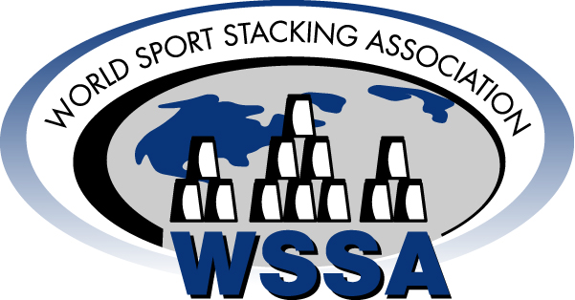

***Questions?*** Call Glenn Costello (860)886-2828 or email rungdc@aol.com

Information may also be acquired by visiting the [www.thewssa.com](http://www.thewssa.com) *website.*

**Mail to: CSC- Glenn Costello-Director, 75 Lafayette St., Norwich, CT 06360**