**WSSA 2018 11th Annual**

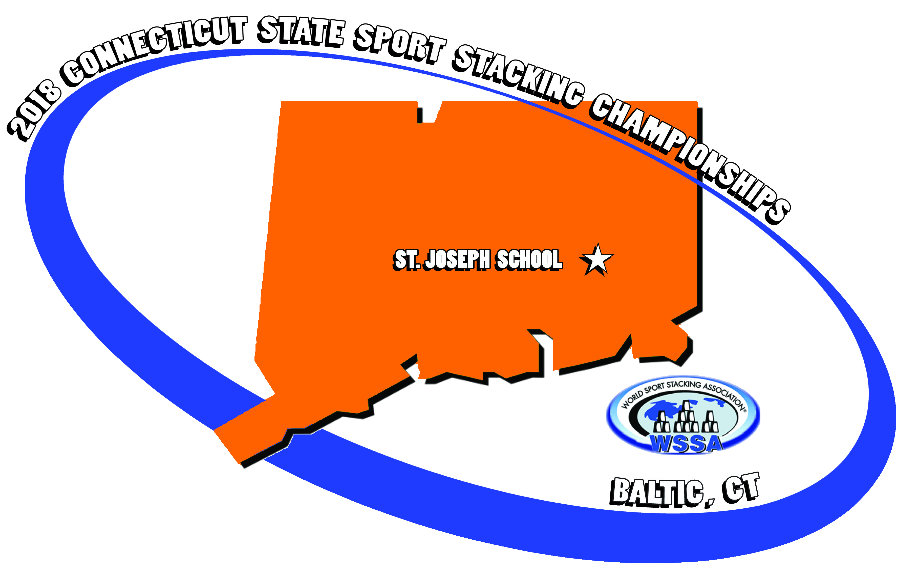

**Connecticut State**

**Sport Stacking**

**Championships**

**Saturday, October 29th 8:00 am to 3:00 pm St. Joseph School-Baltic, CT**

# ***Early Registration ends October 15th!!!!***

**LOCATION:** St. Joseph School(down the hill from St. Michaels Ctr.) 10 School Hill Rd. Baltic, CT 06330

**START TIME:** We will begin at **8:00am** sharp!!!

**\*\*\*IMPORTANT: We are looking for stackers and their parents to be judges for this year-please check the registration form where it asks for judges-we really need all to help out.**

**AGE LEVEL DIVISIONS:** Stackers will compete in the following Age Divisions— 6 & under, 7- 8, 9-10, 11-12, 13-14, 15-18, Collegiate (19-24), Masters-(25-up). Separate Girls and Boys Individual Events will be offered for all Age Divisions except for Masters. Kids in the same grade can still compete on the same team even though they may be 1 year apart! Remember, you can “play up”.

**Competitive Events:** All age divisions offered! Competitive events include **Individual and Doubles Timed Competition,** and **4-Person Team Relays.** For Individual Timed Competitions, all age divisions will compete in the 3-3-3, 3-6-3 and the Cycle stacks. Doubles compete in the Cycle stack. For the 4-Person Team Relays, all age divisions will compete in the Timed Cycle Relays. Stackers compete according to their age division. A special “StackOut” competition will also take place(Top 8 Girls/Boys will compete after Pre-Lims.)

**COMPETITOR REGISTRATION FEE:** $35 FOR OUTSIDE STACKERS $12 FOR STUDENTS FROM ST. JOES, SACRED HEART, AND ST. JAMES SCHOOLS $13 LATE REGISTRATION (AFTER OCT. 15)

**SPECTATOR GENERAL ADMISSION:** $1 FOR ALL NON-STACKING PARTICIPANTS/SPECTATORS/PARENTS

……………To help defray the cost of refreshments

**For more information and/or a complete tournament and registration packet contact:**

**Glenn Costello at (860)886-2828, or rungdc@aol.com**

### Important Notes……

**Opening Ceremonies:** including the playing of our National Anthem, and a very detail explanation of the day’s events.

**CONNECTICUT Sport Stacking Championship T-shirts available DAY OF COMPETITION:** Official 2018 Connecticut Sport Stacking Championships t-shirts can be pre-ordered for $20-shirts will be printed/ordered on October 8th……..NO TSHIRTS WILL BE AVILABLE FOR PURCHASE ON COMPETITION DAY!!!!

**Speed Stacks*®* Merchandise available for purchase:**  Speed Stacks, The Leader in Sport Stacking, will have all it’s latest sport stacking products on hand for individual purchase, while supplies last in the product sales area.

**Food, food, food!**  Will be available in our concession area throughout the day…..but you are welcomed to bring your own bag lunch.

**AWARDS!** Lots and lots of awards will be awarded to the top stackers in each age category of the various events.

**INDIVIDUAL RELAY:** Test your fitness level with this fun and invigorating event!

\*\*\***STACK OF CHAMPIONS:** We will be conducting a final round for the

Top 3 overall in the three Individual events to possibly move up in rankings and have the opportunity

to break State, National, and WORLD records!!! Very

exciting way to end a day of superior stacking!!

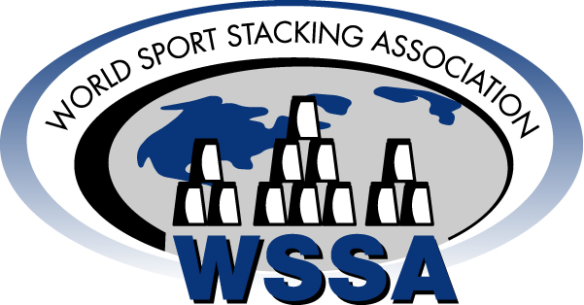

**Fun for the whole family! Lots of ways to participate! Compete! Volunteer to help out! Cheer on the stackers!**

**Be a part of this exciting event!**