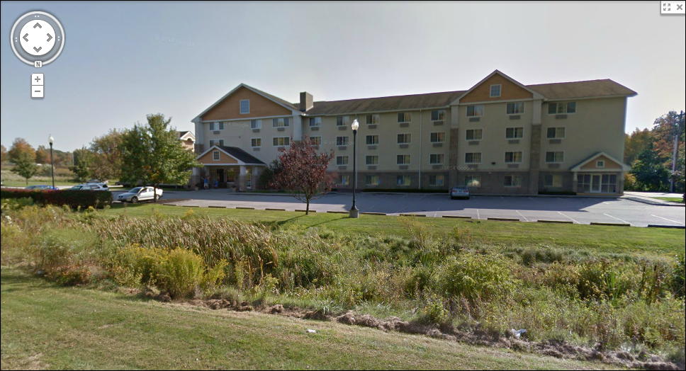 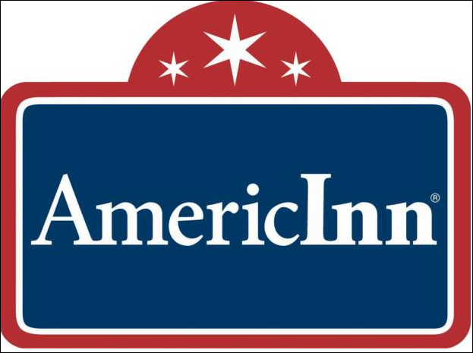

**AmericInn Lodge & Suites Griswold**

***375 Voluntown Road, Griswold, CT  06351***

***860-376-3200***

***AMERICINN.COM***

We have again secured a host hotel for our CT. Championships with a drastically reduced group rate for all of our stackers. The AmericInn in Griswold has agreed to house all out-of-town stackers for a fifth year (block of ten rooms) for two nights **(Oct. 26-27)** at $89.90/night….but you must reserve your room by……..

**Oct. 15**

When you make your reservations either by phone or internet, please use the code….“ctstates”

to be locked in for the two day savings.

The hotel is directly off I-395-exit 22(Old Exit 85). The hotel is approx. 8½ miles from St. Joseph School-Exit 18(Old Exit 83). There are two major shopping areas one exit south-Exit 21(Old Exit 84-S) in Lisbon….Lisbon Landing anchor stores are Walmart, Dicks, Kohls, Home Depot, Ruby Tuesday, and a Digiplex Movie Theater. Lisbon Crossing is across the street and has a Target, Lowes, Aldis, GNC, and Game Stop.

There will be a practice time available for all stackers within the hotel in one of their meeting rooms the night before the Championships….Pre-registered stackers will have their packets available for pick-up that evening……more info will be forthcoming.

***MAKE YOUR RESERVATIONS NOW!!!!!!***

